Goal: This document lists XY’s issue of generating 2-parameter bifurcation plot for PNF 1M8 model

Issues:

1. Never reach the upper boundary
2. “MX”, i.e. not converging problem, persists regardless of the tuning of Xpp-aut running parameters when sweeping negatively from the 2nd branch (whose end point is labelled 52 in the figure below)

Current Result:

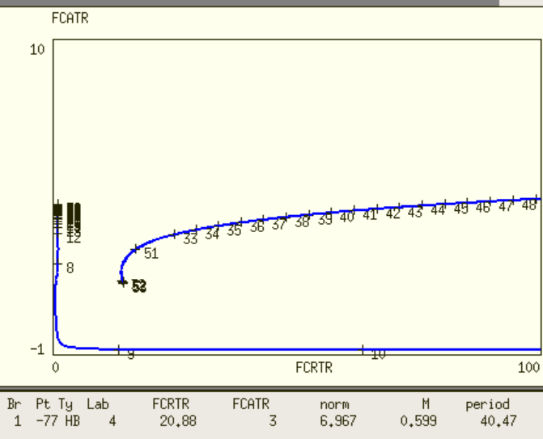

2-parameter bifurcation for PNF-1M8 (Notice that the y-axis is FCATR, yet in the ode file, Amax = 10^FCATR for the purpose of testing the upper boundary)

Testing:

Since we are not interested in parameter regime of FCRTR>=1000, where the oscillatory period is >=1000, focus is shifted towards FCATR<=200, FCRTR<=100

1. FCRTR = 0.1, FCATR = 20

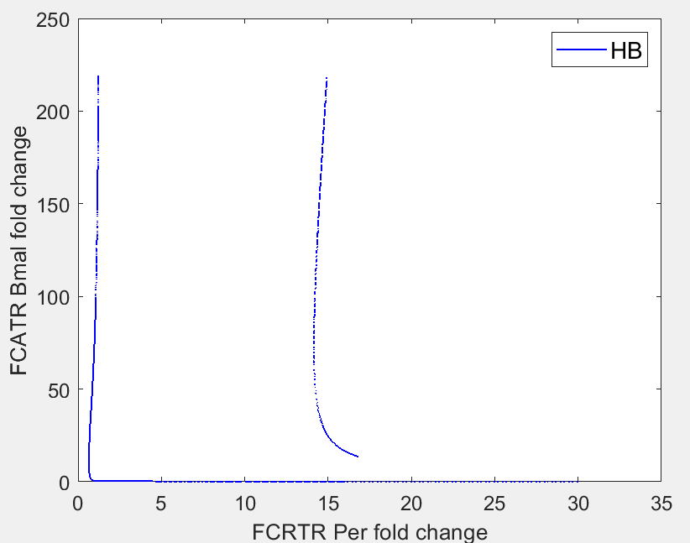

1. FCRTR = 0.1, FCATR = 30

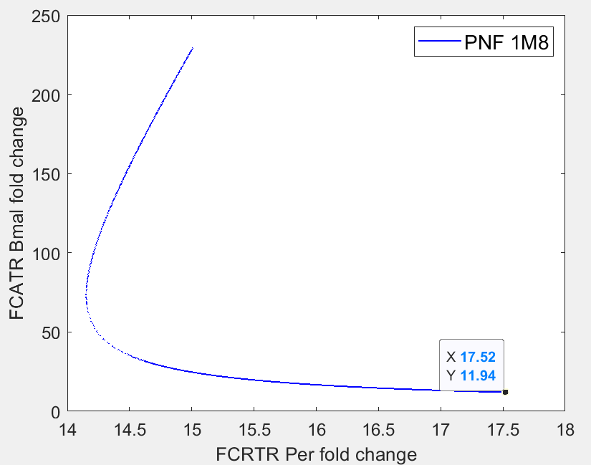

1. FCRTR = 0.1, FCATR = 12

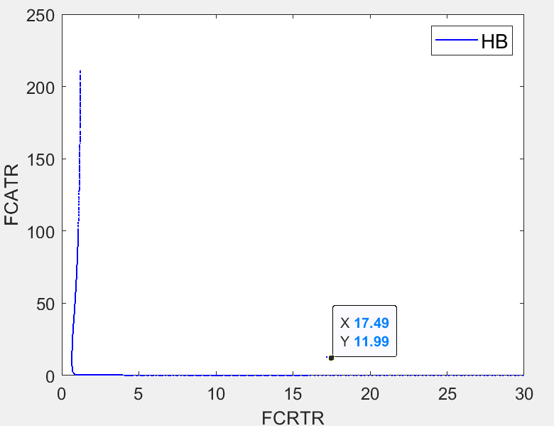

1. FCRTR = 20, FCATR= 13

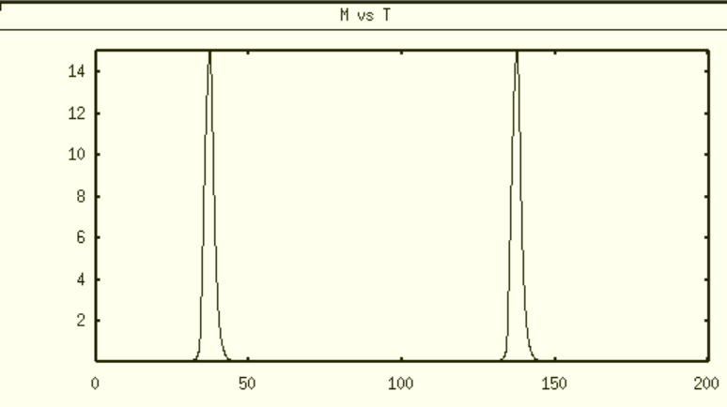

1. FCRTR =20, FCATR =15

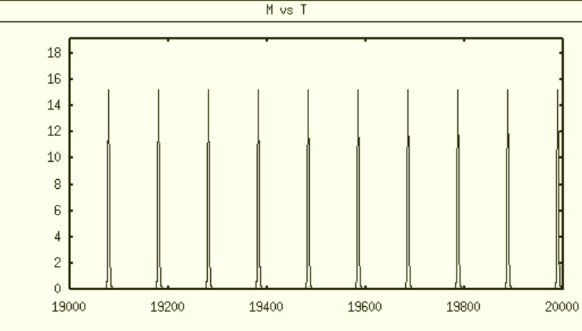

1. FCRTR=20, FCATR=20, the system reaches fixed point

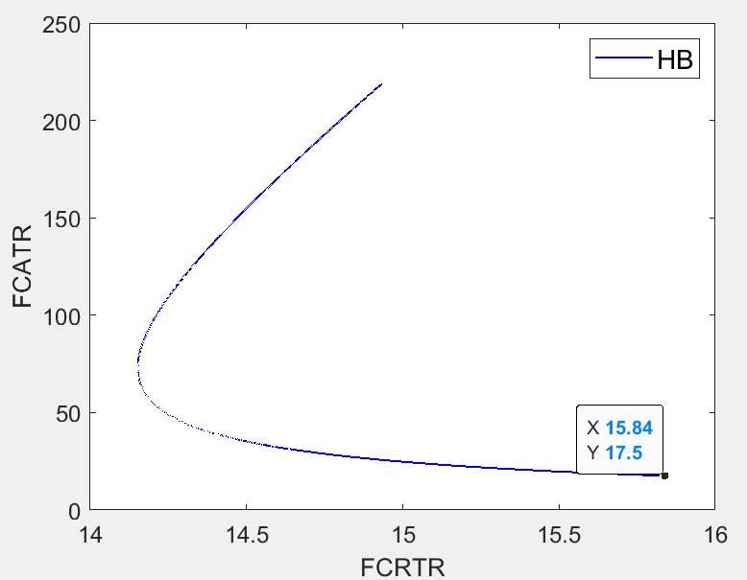

7) FCRTR=20, FCATR=1

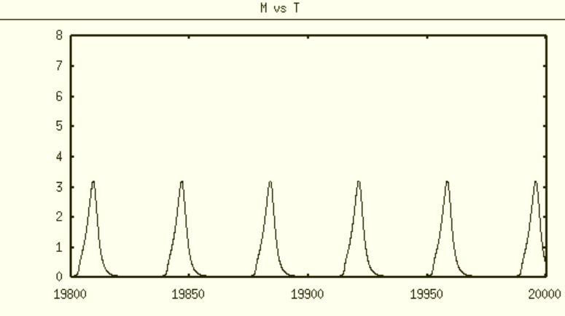

Plot with FCATR as x-axis and FCRTR as y-axis

1. FCATR = 20, FCRTR =20

